07/07/2022
Online Membership Application
Training Guidance

Online Membership APplication

General information about the Online Membership Application:
- Prospective members can access the form at:
  - https://new-member-connect.premierinc.com/public/joinus/adventisthealth
- The online form offers 2 paths of actions to prospective members:
  - request to be contacted by a representative.
  - enroll online

How to Complete the Online Membership Application

PATH 1: Request Contact from a representative
1. | Open the Online enrollment form.
2. | Fill in the demographic information on the New Member Form  - First Name  - Last Name  - Suffix  - Title  - Class of Trade (Use the Healthcare and Non-Healthcare hyperlinks for definitions)  - Organization Name  - Phone Number  - Business Address Line 1  - Business Address Line 2  - City  - State  - Zip Code  - Email Address  - Confirm Email Address
3. | Choose Yes or No if you were helped by a supplier.  If you choose yes, provide answers to the following additional fields, which will appear:  - Supplier Name  - Contact First Name  - Contact Last Name  - Contact Email Address  - Contact Phone
4 | Click on I want to be contacted by Adventist Health.

PATH 2: Enroll online
1. | Open the Online enrollment form.
2. | Fill in the demographic information on the New Member Form  - First Name  - Last Name  - Suffix  - Title  - Class of Trade (Use the Healthcare and Non-Healthcare hyperlinks for definitions)  - Organization Name  - Phone Number  - Business Address Line 1  - Business Address Line 2  - City  - State  - Zip Code  - Email Address  - Confirm Email Address
3 | Click on I’m ready to start membership registration.
4 | - Select a GPO Start Date by clicking on the Calendar Icon. (Defaults to the day you are completing the online form.)  - 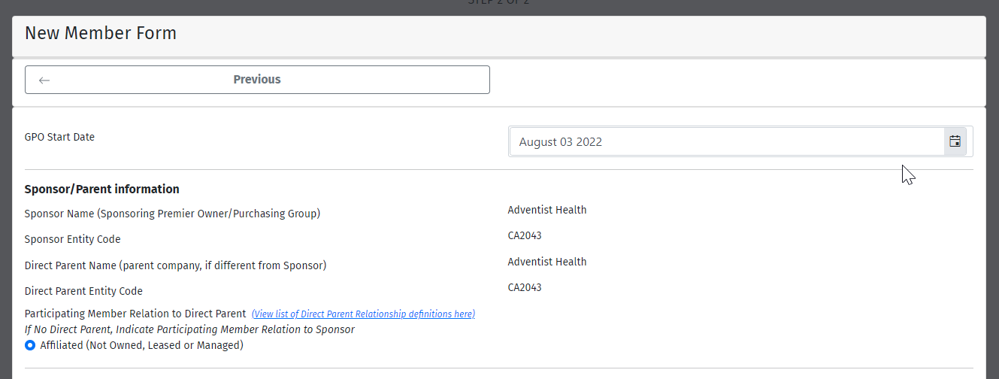
5 | Enter unique identifiers.  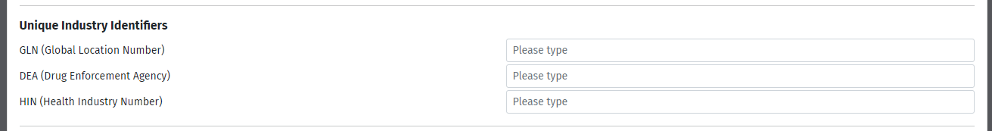
6 | Enter any additional contacts. (if applicable)  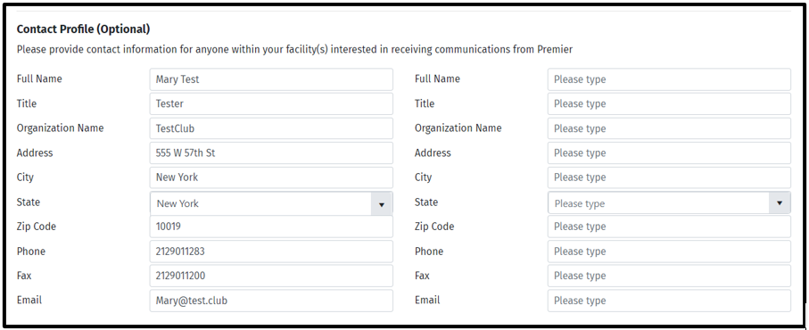
7 | For prospective members enrolling multiple locations:  - Download and Complete the excel spreadsheet template.  - Once the excel spreadsheet is saved, click on Select Files and click on the saved file.  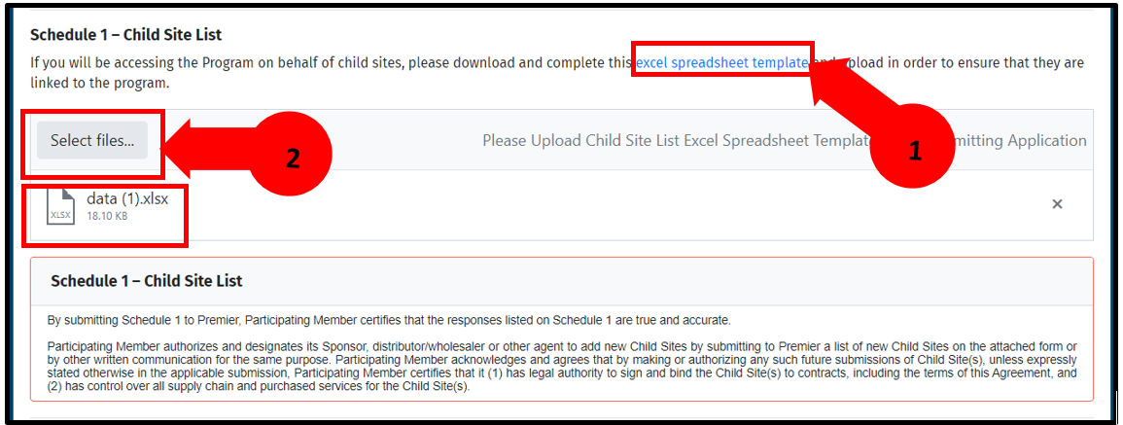
8 | Read and Accept the Terms and Conditions  Note: The exhibits forms are based on the class of trade that is selected. Some Classes of Trade require additional exhibits. Example: Exhibits B is required for Pharmacy Line of Business.  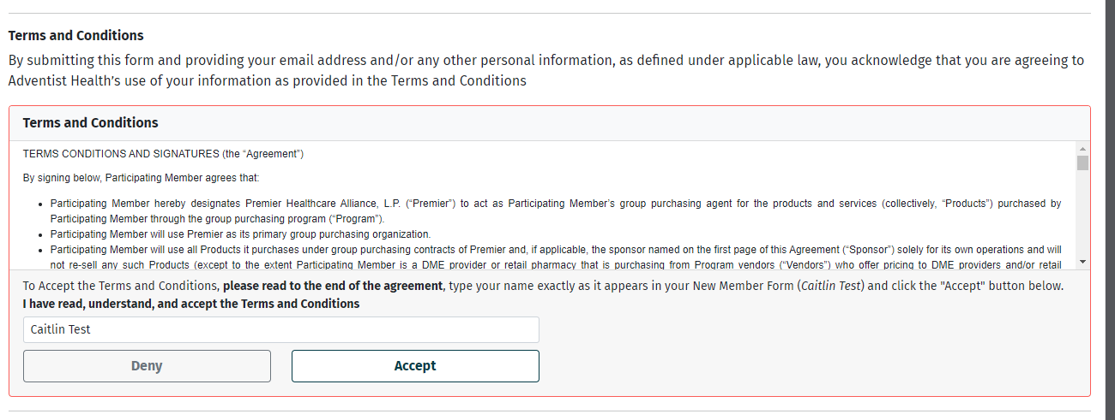
9 | Click on Submit my completed New Member application.  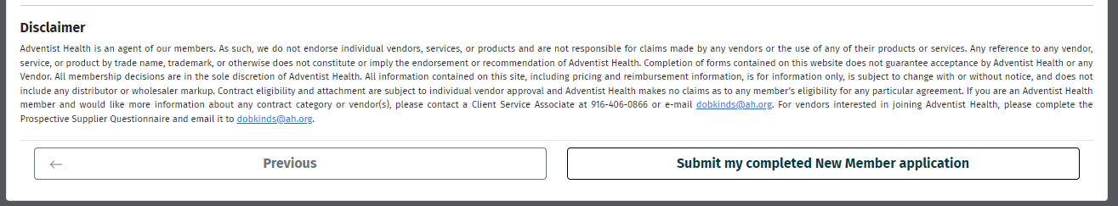

Next Steps after Online Membership Application Completion

PATH 1: Request Contact from Adventist Health
When the form is completed:
- a group email is sent advising the team of the new prospect
- a prospects record is created in Premier’s systems
- The user sees a splash page confirming submission

PATH 2: Enroll online
When the forms are completed:
- The Premier membership team gets an email containing all the details including a copy of the membership paperwork
- a prospect record is created in Premier’s systems
- The users sees a splash page confirming submission

